RingCentral offers quality business phones featuring HD voice and
powerful features that optimize productivity. They arrive Plug & Ring® ready, so no manual configuration is required and free technical support is included.
Polycom VVX-500 / Color Touchscreen Desk Phone
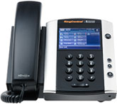

$299.00 List Price $339.00 or $20.00/month
$499.00 List Price $539.00 or $32.00/month Polycom VVX 500 + 1 Expansion Module
Phone rental available with RingCentral Office multi-year contract.
A revolutionary color touchscreen IP phone with speakerphone, presence, Gigabit ethernet, and more. Includes power adapter.
- 12 touch keys can display the presence status for up to 10 users on the phone display
- Intelligent context-based softkeys
- Future expansion via USB flash drive, camera, and other options
- Large backlit capacitive multi-touch display
- Polycom HD (high-definition) voice technology
- Share a single network connection with your phone and PC using the integrated 2-port Gigabit Ethernet switch
- Dedicated RJ-9 headset port
- Integrated Power over Ethernet (PoE) support (Class 2)
Turn your business phone into a high performance attendant console. This is an optimal solution for telephone attendants and power users who manage multiple, simultaneous telephone calls or monitor presence on a daily basis.
- 40 additional presence lines with a single expansion module
- Augments host phone user interface
- Easy installation

Cisco SPA525G2 / Advanced Executive Color IP Phone
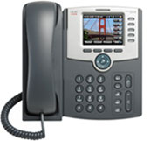

$279.00 List Price $319.00 or $18.00/month
$369.00 List Price $409.00 or $25.00/month Cisco SPA525G2 + 1 Expansion Module
$459.00 List Price $499.00 or $30.00/month Cisco SPA525G2 + 2 Expansion Modules
Phone rental available with RingCentral Office multi-year contract.
An advanced executive phone with speakerphone, bluetooth, WiFi, high-resolution color display, and more. HD-voice capable for ultra-clear audio. Includes power adapter.
- High-resolution color display for easy call-handling and additional features including photo display
- Bluetooth connectivity enables use of the phone as a headset for a mobile phone
- WiFi connectivity eliminates the need for an ethernet cable
- Five line keys – easily manage up to 5 simultaneous calls
- Integrated Power over Ethernet (PoE) support
- Integrated 2-port ethernet switch so you can connect a PC or other device in addition to the phone
Turn your business phone into a high performance attendant console with this optimal solution for telephone attendants, receptionists, administrative assistants and secretaries.
- 32 additional lines per expansion module
- Augments user interface
- Can be added or removed from host phone at any time

Polycom VVX 410 / Color Gigabit Ethernet Phone
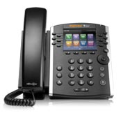

$219.00 List Price $259.00 or $13.00/month
$419.00 List Price $459.00 or $25.00/month Polycom VVX 410+ 1 Expansion Module
Phone rental available with RingCentral Office multi-year contract.
Your Price: $419.00 List Price $459.00
Polycom VVX 410 Color Gigabit Ethernet Phone
A color display IP phone with speakerphone, presence, Gigabit ethernet, and more. Includes power adapter. 12 line keys with ability to display the presence status for up to 10 users on the phone display.
- Intelligent context-based softkeys
- Backlit 3.5” color Color display with 320 x 240 resolution
- Polycom HD (high-definition) voice technology
- Share a single network connection with your phone and PC using the integrated Gigabit 2-port Ethernet switch
- Dedicated RJ-9 headset port
- Integrated Power over Ethernet (PoE) support (Class 2)
Turn your business phone into a high performance attendant console. This is an optimal solution for telephone attendants and power users who manage multiple, simultaneous telephone calls or monitor presence on a daily basis.
- 40 additional presence lines with a single expansion module
- Augments host phone user interface
- Easy installation

Cisco SPA514G Gigabit Desk Phone
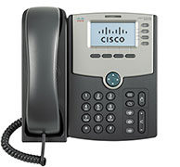

$169.00 List Price $209.00 or $12.00/month
$259.00 List Price $299.00 or $18.00/month Cisco SPA514G + 1 Expansion Module
$349.00 List Price $389.00 or $24.00/month Cisco SPA514G + 2 Expansion Modules

Phone rental available with RingCentral Office multi-year contract.
An advanced desk phone with speakerphone, 4 line keys, Presence and Gigabit network interface. HD-voice capable for ultra-clear audio. Includes power adapter.
- 4 line keys displaying the presence status for up to 2 users on phone display
- Backlit graphical display for easy call-handling
- Integrated Power over Ethernet (PoE) support
- Integrated 2-port Ethernet switch so you can connect a PC or other device in addition to the phone
- Add expansion modules to monitor presence of additional colleagues
Turn your business phone into a high performance attendant console with this optimal solution for telephone attendants, receptionists, administrative assistants and secretaries.
- 32 additional lines per expansion module
- Augments user interface
- Can be added or removed from host phone at any time

Cisco SPA508G 8-Line IP Phone
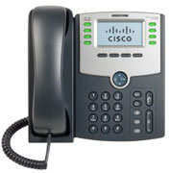

$199.00 List Price $239.00 or $13.00/month
$289.00 List Price $329.00 or $18.00/month Cisco SPA508G + 1 Expansion Module
$379.00 List Price $419.00 or $22.00/month Cisco SPA508G + 2 Expansion Modules

Phone rental available with RingCentral Office multi-year contract.
A full featured 8 line business class IP phone with speakerphone, caller ID, mute and more. The phone includes dedicated buttons for voicemail, mute, hold, speaker, headset, and common functions. Includes power adapter.
- Share a single network connection with your phone and PC using the integrated 2-port Ethernet switch
- Wideband audio for unsurpassed voice clarity
- Supports 8 lines
- Monochrome backlit display
- Integrated power over Ethernet (PoE) support (class 2)
- Monitor presence status of up to 6 colleagues
- Add expansion modules to monitor presence of additional colleagues
Turn your business phone into a high performance attendant console with this optimal solution for telephone attendants, receptionists, administrative assistants and secretaries.
- 32 additional lines per expansion module
- Can be added or removed from host phone at any time

Polycom VVX 310 Gigabit Ethernet Phone
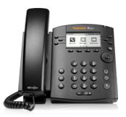

$169.00 (List Price $209.00) or $9.00/month
Phone rental available with RingCentral Office multi-year contract.
A high-resolution display IP phone with speakerphone, presence, Gigabit ethernet, and more. Includes power adapter. 6 line keys with ability to display the presence status for up to 4 users on the phone display.
- Intelligent context-based softkeys
- Backlit monochrome display with 208 x 104 resolution
- Polycom HD (high-definition) voice technology
- Share a single network connection with your phone and PC using the integrated Gigabit 2-port Ethernet switch
- Dedicated RJ-9 headset port
- Integrated Power over Ethernet (PoE) support (Class 2)

Cisco SPA 303 Business IP Phone
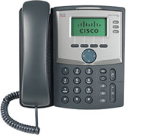

$119.00 List Price $159.00 or $8.00/month

Phone rental available with RingCentral Office multi-year contract.
A full-featured IP phone with speakerphone, caller ID, call hold, mute, and more. Affordable, reliable, and easy-to-use.
- 3-line business-class IP phone
- Dual switched Ethernet ports, speakerphone, caller ID, call hold, conferencing, and call swap
- 2-port Ethernet switch
- Easy installation, web-based configuration
- Requires an external power adapter for Power over Ethernet (POE) support

Polycom IP 335
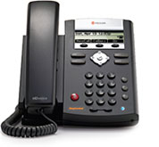
$139.00 List Price $179.00 or $5.00/month

Phone rental available with RingCentral Office multi-year contract.
A full-featured business phone with speakerphone, caller ID, call hold, mute, and more. Includes power adapter.
- Polycom HD (high-definition)voice technology*
- Backlit display
- Share a single network connection with your phone and PC using the integrated 2-port Ethernet switch
- Dedicated RJ-9 headset port
- Two line keys – easily manage up to 2 simultaneous calls
- Easy to configure and use
- Integrated Power over Ethernet (PoE) support (Class 2)

Polycom IP 321
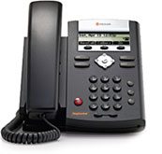
$99.00 List Price $139.00 or $5.00/month

Phone rental available with RingCentral Office multi-year contract.
A full-featured business phone with speakerphone, caller ID, call hold, mute, and more. Includes power adapter.
- Two line keys - easily manage up to 2 simultaneous calls.
- Easy to configure and use.
- Integrated Power over Ethernet (PoE) support (Class 2)

Yealink W52P Cordless Phone
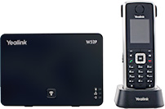
$169.00 List Price $199.00 or $12.00/month Yealink W52P
$279.00 List Price $339.00 or $19.00/month Yealink W52P + 2 handsets
$389.00 List Price $479.00 or $26.00/month Yealink W52P + 3 handsets
$499.00 List Price $619.00 or $33.00/month Yealink W52P + 4 handsets

Phone rental available with RingCentral Office multi-year contract.
Available with additional handsets
Base + 2 handsets
Your Price: $279.00 List Price $339.00
Base + 3 handsets
Your Price: $389.00 List Price $479.00
Base + 4 handsets
Your Price: $499.00 List Price $619.00
The Yealink W52P cordless phone solution is ideal for users that need in-office mobility. Ideal for small business that need plug and play wireless technology.
- DECT cordless technology for secure communications
- HD voice technology
- Backlit 1.8" color display
- Provision up to 4 handsets per base
- Up to 4 simultaneous calls per base.

Cisco SPA 122
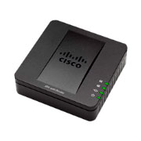
$79.00
List Price $119.00
Or $5.00/month

Phone rental available with RingCentral Office multi-year contract.

